Instructions for using the NURSING DEFERRED EMPLOYEE BENEFIT
Are you a nurse who is enrolled in the UD RN to BSN, RN to MSN, or MSN program and your employer offers tuition benefits that will allow you to be reimbursed after grades are submitted? The University of Delaware will grant authorization to defer payment until 30 days after grades are received to allow time for reimbursement.
Please review the instructions below prior to course registration and send any additional questions to ud-nursing@udel.edu
- Register for your course : http://www.pcs.udel.edu/reg/credit/index.html
- When a new statement is available, you will receive an email notification to login and view your bill from Student Financial Services
- Login to your “My Finances Page” to view your bill *YOU WILL NOT GET A PAPER BILL
- The My Finances Page will show an overview of what you owe and the due date. Go to the bottom of that page and click Next Step
- Click Yes for reporting additional credits
- Pick Nursing Deferred Employee Benefit
You will get the following message:
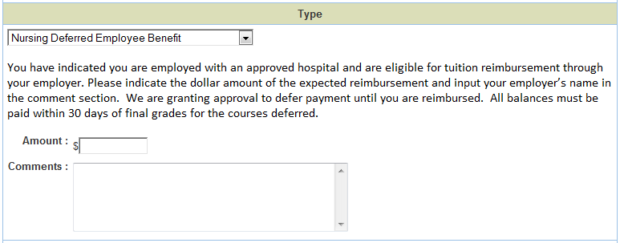

- Fill in the $dollar amount you are offered through your employee tuition benefits and the name of your employer. Example: $3,000 through Dover Hospital * Note: you should only put here what you have eligible to spend for this time period. For instance, if you get $5,000 a year, but have already spent $2,000, you should only put that you are eligible for $3,000. If you indicate an amount of coverage less than what is owed, you will be expected to pay that difference when the bill is normally due.
- -PRINT SCREEN NOW -
Hold onto this printed copy and plan to submit to your employer / HR as proof of enrollment in the UD Deferred Billing Program
- Next Step at the bottom of the page
- Payment Page with payment options for the balance that is remaining (if any).
- Payment Method Page *note the 2.75% fee for credit card payments and no VISA allowed *online check option * mail in physical check option (due to S.F.S. by payment date)
- Total Payment Page
- Check Disclaimer and enter an email address to get confirmation *you will receive notification if there is any payment issues
- Next Step
- Complete payment with a credit card number or bank routing number
- SUBMIT *It is important to hit submit to ensure we receive notification that you are requesting this benefit to ensure we do not assess late fees for non-payment.

Reminder: By requesting this deferral of payment you are agreeing to submit payment within 30 days of grades being received. If you are unable to make payment for any reason it is important that you can contact Student Financial Services at sfs-advisor@udel.edu to make alternative arrangements to keep your account current.

